**Name: Nikhil Jais**

**Roll No: 25**

**Batch: B**

**Date: 04-04-2022**

**NETWORKING & SYSTEM ADMINISTRATION LAB**

**Experiment No.: 5**

**Aim**

Familiarization of Linux Commands – Part 03

**Procedure**

1. **cp [filename 01] [filename 02]:** This command is use to copy the contents of the mentioned source file to the mentioned destination file.



* 1. **cp [filename 01] [filename 02]:** Here, if the file 02 already exists the old data of the file is overwritten by the data of the source file.



1. **cp -i [filename 01] [filename 02]:** This command is used when you copy contents of a file to an existing file. This command shows a confirmation message whether you want to overwrite the existing data with the new data before any changes.



1. **cp -r [foldername 01] [foldername 02]:** This command is used to copy all files from the source along with the folder into the destination folder recursively.

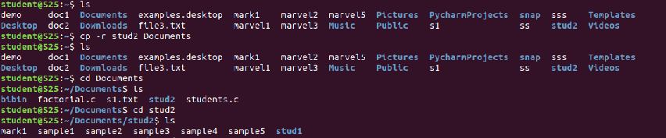

1. **mv [filename] [foldername]:** This command is used to move a source file to the desired mentioned destination folder.

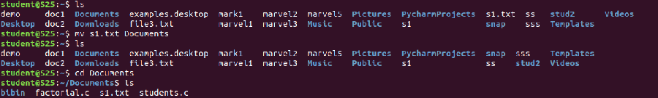

1. **mv -i [filename] [foldername] :** This command is used to move a already existing source file to the destination. Before moving the file, the confirmation is asked whether the data of the already existing file to be replacing with the new data of the file.

